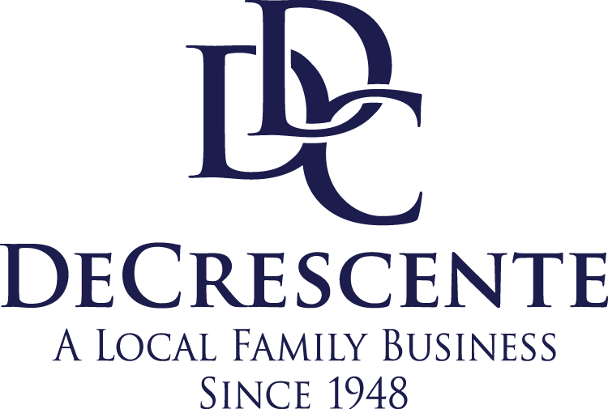

FOR IMMEDIATE RELEASE

For more information:
MacKenzie Zarzycki
DeCrescente Distributing Company
(518) 275-3151
m.zarzycki@ddcbev.com

DeCrescente Distributing Company Now Distributes BANG® Energy Drink

Mechanicville, NY – March 15, 2019 – DeCrescente Distributing Company (DDC) is excited to announce a partnership with VPX Sports to distribute BANG® Energy Drink, a great-tasting 16-ounce carbonated beverage formulated to fuel the brain and body. BANG® is now available in 12 unique flavors like Sour Heads and Purple Haze throughout the Capital Region.

“BANG® is not your typical high-sugar, health-robbing beverage. Rather, BANG® consists of several patent-pending compounds and patented compositions intelligently designed to deliver results without the sugar-induced metabolic mayhem and crash,” explains Jack Owoc, CEO and chief science officer of VPX Sports.

Current commercially available energy drinks use high levels of sugar, which instantly boost your insulin levels. When the caffeine and sugar leaves your body, your hormone levels normalize, which causes the fatigue known as the “crash.” BANG® incorporates creatine, glutamine and other amino acids including BCAA’s (branched-chain amino acids) that provide both immediate and long-term energy without the crash. BANG® goes above and beyond the expectations of typical short-term energy beverages in this category.

BANG® contains 300mg of caffeine, 0 sugar, 0 carbs and 0 calories. It’s ideal for gamers, fitness enthusiasts, athletes, extreme sports, CrossFit, and as a pre-workout for bodybuilders or anyone desiring a delicious-tasting carbonated beverage that doesn't contain sugar. BANG® provides clean energy, laser-sharp focus and no sugar-induced crashes.

“The beverage innovators at VPX Sports have redefined the energy drink category with this well-researched and effective energy drink,” said DDC General Manager, Russ Teplitzky. “BANG® tastes incredible and I can’t wait for consumers to try it!”

The growth of BANG® has been phenomenal because of its powerful global social marketing appeal. The energy drink currently has more than 92 million social media followers fueled by a super progressive concert-style global experiential marketing campaign called The Bang Revolution World Tour. Check them out on Instagram @bangenergy!

For more information regarding BANG® energy drink, please visit http://www.decrescente.com/products.

About DeCrescente Distributing Company
DeCrescente Distributing Company (DDC) is a fourth-generation beverage distributor, family-owned and operated since 1948. DDC takes great pride in its employees, customer service and community involvement. Most notably, DDC was awarded Best Places to Work in the Capital Region for nine consecutive years and employs more than 400 people. Some of the company’s brands include Polar, Snapple, Saratoga Water, MillerCoors, Boston Beer Co., New Belgium, Heineken, Corona, Yuengling, FX Matt Brewing Company, and Guinness. DDC also distributes a unique variety of local craft beers as well as wine and spirits. Some of the local favorites include Artisanal Brew Works, Adirondack Brewery, Brown’s Brewing, Druthers Brewing, Upstate Distilling, Saratoga Winery, and Saratoga Courage Distillery. For more information, please visit www.ddcbev.com.

About Vital Pharmaceuticals, Inc. d/b/a VPX Sports:
VPX was founded in 1993 with one goal in mind: to produce the highest grade, university-proven sports supplements and performance beverages in the world. VPX has delivered on its promise by funding over 24 landmark, human-subject studies on its products, including BANG®, at UCLA, University of South Alabama, Florida State University, Baylor, University of Southern Maine, Memphis University, College of New Jersey, FIU, and other top universities in the country. VPX continues to update and release new nutrition products, proudly maintaining its distinction as the "Frontrunner in Sports Nutrition." VPX is orchestrated by the world's leading authority, author, and developer of performance-enhancing supplementation and physique-altering nutrition—Founder and CEO, Jack Owoc.

-###-

