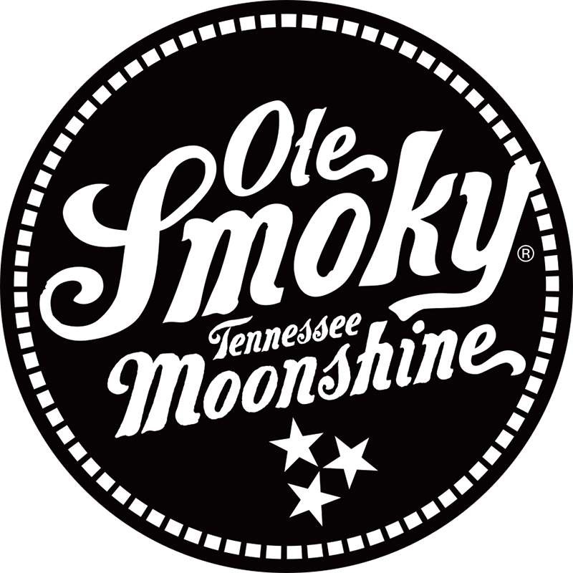
Media Contact: Paul Lindsley
Paul.lindsley@phase3mc.com
615.585.3487

OLE SMOKY® INTRODUCES MOONSHINE-BASED CANNED COCKTAILS
The distillery launches ready-to-drink canned cocktails across Tennessee

Nashville, TN. — (July 14, 2020) – Today, Ole Smoky Distillery, the most visited distillery in the world and #1 moonshine brand in the U.S., introduces its newest line of products – refreshing, delicious and convenient canned cocktails you can enjoy at home, on the beach or lake, or hanging out with friends.

The ready-to-drink cocktails are “made with a kick,” featuring Ole Smoky’s famous moonshine. Four tasty flavors Apple Pie Ginger, Blackberry Lemonade, Mountain ‘Rita, and Mountain Mule are rolling out across Tennessee at liquor stores, local marinas, and at Ole Smoky’s Nashville Distillery, 6th & Peabody at 423 6th Ave South. All flavors are packaged in 12oz cans and sold in packs of four.

“We are thrilled to release these new moonshine canned cocktails in Tennessee. As the #1 moonshine brand in the country, we continue to create high quality, great tasting, craft spirits,” said Robert Hall, CEO, Ole Smoky Distillery. “Our new Ole Smoky Canned Cocktails are made with our authentic Tennessee moonshine, allowing customers to indulge in high quality cocktail experiences while enjoying the convenience of a can.”

Ole Smoky Moonshine Canned Cocktails flavors contain 9% alcohol by volume and were created based on the best-selling Ole Smoky cocktails served at Ole Smoky’s Nashville distillery, 6th & Peabody, and in bars and restaurants where Ole Smoky is served. Flavors include:

Apple Pie Ginger
Spice up your evening with a little all-American goodness. Our Apple Pie Ginger combines the taste of baked apple pie with zesty ginger and results in a spicy, fruity cocktail that’s ready to go! No mixing required.

Blackberry Lemonade
Summer may have been invented for Blackberry Lemonade cocktails, and ours is easier than ever to enjoy. Pop the top on our Blackberry Lemonade and enjoy juicy, dark berry flavors mixed with a ripe, citrus finish that has a kick.

Mountain ‘Rita
Our Mountain ‘Rita is made with authentic Tennessee moonshine. Upon first sip, you will taste the fresh, citrusy flavors mixed in with all the salty, tart magic of a great margarita. Bring on the sunset!

Mountain Mule
Nothing kicks up a cookout or day on the water like our Mountain Mule. Easy to pour, hard to put down, enjoy the freshness of citrus with a spicy kick of ginger heat. All the great taste of a mule, all in one place.

For more information, please visit www.olesmoky.com and follow Ole Smoky on social media @olesmoky.
# # #

About Ole Smoky® Distillery LLC:
Ole Smoky is the leading distiller of premium moonshine in the world and the first federally licensed distillery in the history of East Tennessee. Founded in 2010, Ole Smoky's roots can be traced to the Smoky Mountains' earliest settlers, families who produced moonshine with enduring pride and Appalachian spirit.

Ole Smoky distilleries are the most visited in the world. In 2019 alone, more than 4.5 million people visited Ole Smoky's four famed Tennessee distilleries: The Holler, The Barrelhouse, The Barn and 6th & Peabody in Nashville.

