FOR IMMEDIATE RELEASE Amy Kaske Berger For KidsLuv
amy@amykaskeberger.com
917.842.0889

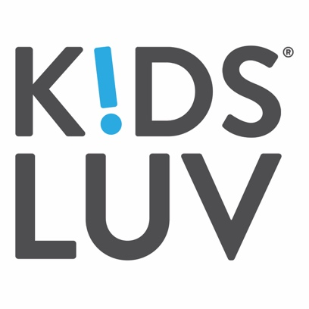

KidsLuv Launches SEC-Regulated Crowdfunding Campaign for
Functional Kids’ Beverage

The Luving Company, creator of KidsLuv, the fast-growing zero sugar functional kids’ beverage,
announced today it is raising funds through an SEC-regulated crowdfunding campaign on StartEngine (StartEngine.com/kidsluv)

(LOS ANGELES, CALIFORNIA, October 6, 2020) – KidsLuv, the Vitamin Enhanced, zero sugar kids’ beverage, today announces it is raising funds through an SEC-regulated crowdfunding campaign on StartEngine.com, which is the leading equity crowdfunding platform in the U.S. KidsLuv is the first product from The Luving Company which was established in 2018 by a mother of three, Ashi Jelinek, and is a female-founded and minority-owned business based in Los Angeles, CA.

KidsLuv is a functional kids’ beverage with zero sugar and Certified Vegan vitamins and minerals, and is currently available in three flavors: Peach Me, I’m Orange; Flying Fla-Mango and Starstruck Coconut. All three flavors have zero sugar, only 10 calories and 2g carbs, essential Certified Vegan vitamins and minerals in each serving, and are 100% clean labeled, Certified Non-GMO, Vegan, Kosher and Gluten-free, and packaged in an 8 oz. recyclable, resealable, straw-free drink carton.

At a time when health is paramount, KidsLuv is centered between two distinct markets: the children’s beverage market and the children’s pediatric supplements market, with a combined market size of over $2.7B (Newsweek, “The Big Problem With Children's Vitamins and Supplements,” and UConn Rudd Center “Children’s Drink F.A.C.T.S. 2019”.)

“We’re pleased to make a crowdfunding offering with StartEngine,” says Ashi Jelinek, Founder and CEO of KidsLuv. “StartEngine is revolutionizing crowdfunding and it’s a great platform for us to engage with our customers. In today’s virtual world, it’s more important than ever to connect with consumers and drive brand awareness online, and we’re thrilled to be able to make deeper connections with our current customer base and grow new fan loyalty through this cutting-edge platform.”

To learn about the raise, visit www.StartEngine.com/kidsluv.

About KidsLuv
KidsLuv is a zero sugar vitamin enhanced beverage created by a mother of three and Shark Tank alumni, Ashi Jelinek, upon recognizing a growing demand in the kids’ beverage space for less sugar and healthier products. Established in 2018, The Luving Company, a female-founded and minority-owned business, launched it’s first brand, KidsLuv, designed to give kids a healthy dose of vitamins and minerals their bodies need, without the harmful sugars. KidsLuv products are currently available online at KidsLuv.com, Thrive Market, Amazon and can be found in Natural Independents Markets, United Supermarkets, Walmart Stores and CVS Pharmacy. For more information about the company and to find a store, visit www.KidsLuv.com and follow on Instagram and Facebook.

About StartEngine
StartEngine is the leading equity crowdfunding platform in the U.S., where everyday people can find and invest in early-growth companies and startups. StartEngine has helped more than 325 companies raise $135M+ from a community of over 235,000 prospective investors. Based in Los Angeles, the company was created in 2014 by Howard Marks, co-founder of Activision, and Ron Miller. StartEngine is committed to revolutionizing the ways companies raise capital through the JOBS Act and helping entrepreneurs achieve their dreams. StartEngine Crowdfunding Inc. is not a broker-dealer, funding portal or investment adviser. StartEngine Capital, LLC is a funding portal registered with the US Securities and Exchange Commission (SEC) and a member of the Financial Industry Regulatory Authority (FINRA). StartEngine Primary LLC is a broker-dealer registered with the SEC and FINRA/SIPC.

###

